CHAPTER 4: Ecosystems
Worksheet 4.4

Nature pyramids
Science Quest 7: pages 122–127
Student: Class:

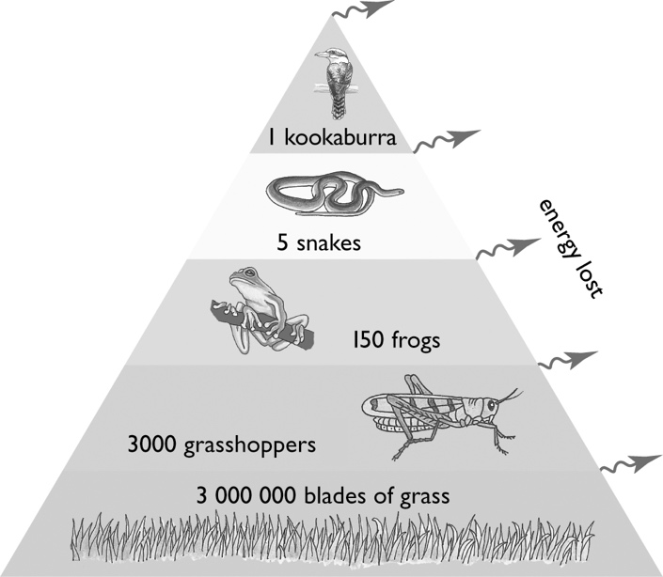
Questions
The following questions relate to the food chain described in the numbers pyramid at right.
1. On the pyramid, label the producers and the order of consumers.

2. Energy flows from the producers in a food chain to each other level in the chain. At each level, 90 per cent of the available energy is transferred to the environment, and so is not available to be passed on to the next level. If 100 per cent of energy is available at the producer level of the food chain, what percentage is available for the organisms at each other level of the food chain? Display your answers in the form of an energy pyramid.
3. There are five organisms represented in this food chain. Explain, in terms of the energy available at each level, why food chains with five or more levels are rare.

4. Look at the numbers of each organism at each level of the food chain. Why are the numbers much larger at the bottom than at the top?

CHAPTER 4: Ecosystems PAGE 2
Worksheet 4.4

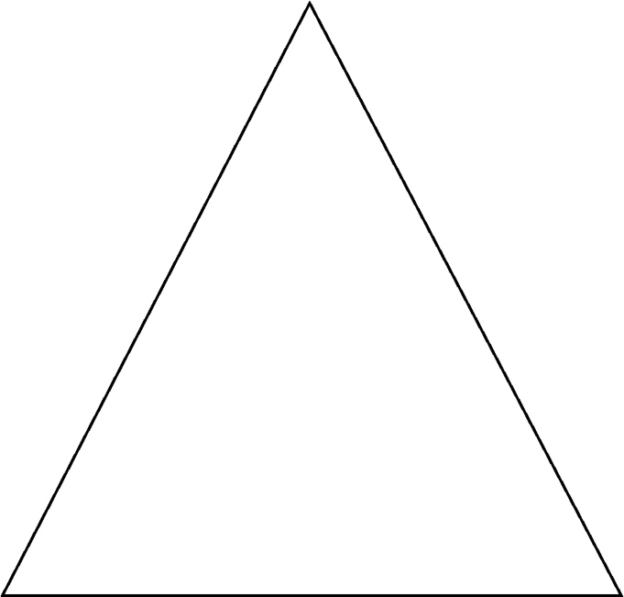
5. Using the numbers pyramid as a guide, sketch an appropriate biomass pyramid for the food chain.
6. A farmer wishes to destroy grass on his farm using a poisonous substance. The manufacturer claims that the recommended dosage is not harmful to insects; that is, a grasshopper can ingest 0.1 milligrams of the poison without being harmed. It is known that animals can, however, become seriously ill if they ingest 0.2 grams of the poison and could die from ingesting 0.5 grams. Using the numbers pyramid above to aid in your calculation, describe how the kookaburra would be affected by the poison after eating five snakes.

7. To avoid poisoning any animals, the farmer in question 6 decides, instead, to use a non-toxic weed killer to kill off the grass in a section of his farm. How will this affect the survival of the kookaburra? Explain your answer.

